1. relative vs absolute positioning in css

Relative - the element is positioned relative to its normal position.

Absolute - the element is positioned absolutely to its first positioned parent.

1. css box sizing and more precisely margin vs padding

CSS margins determine the space surrounding an element, therefore margins would be used to move an element up or down on the page, as well as left or right. If the width of your page is fixed, centering an element horizontally : margin: auto.

A CSS box consists of the margin, border, padding, and content — as shown below:

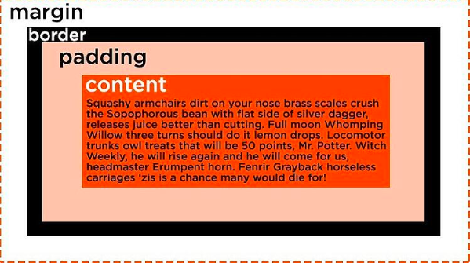

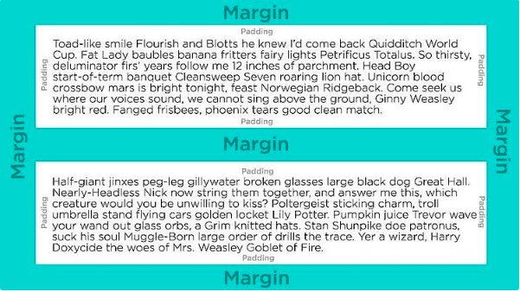

margin-top, margin-right, margin-bottom, and margin-left

To set the padding, use padding-top, padding-right, padding-bottom, and padding-left properties. Alternatively, you can use the shorthand property padding

So, margin defines the space between different elements but padding defines the space between the content of the element and its border.